Assignment 3: Wireshark Lab

Name: Atish Kadam
Roll Number: CS25MTECH14003

Part - A IPV4

Part -1 Basic IPV4

Ans -
First Datagram as we send When we send a datagram of Size 56 - Packet No. 9 is the first one.

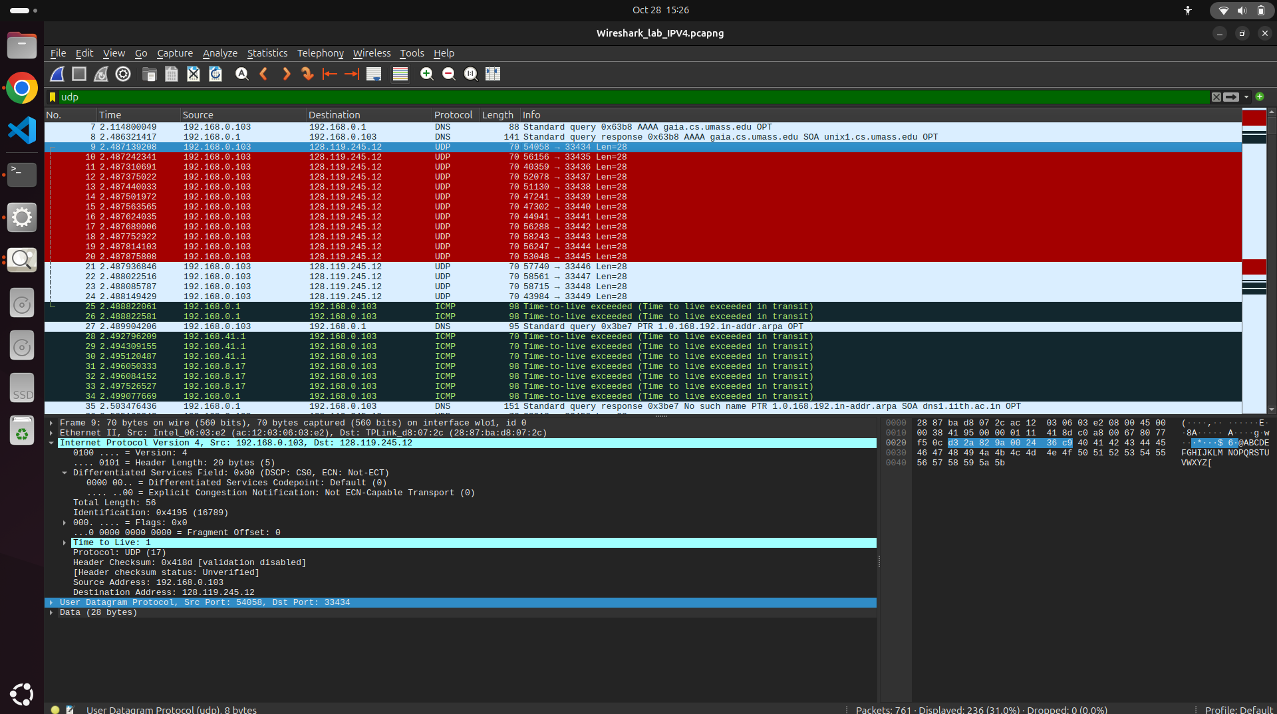
First Datagram as we send a datagram of Size 3000- Packet No. 235 is First one.
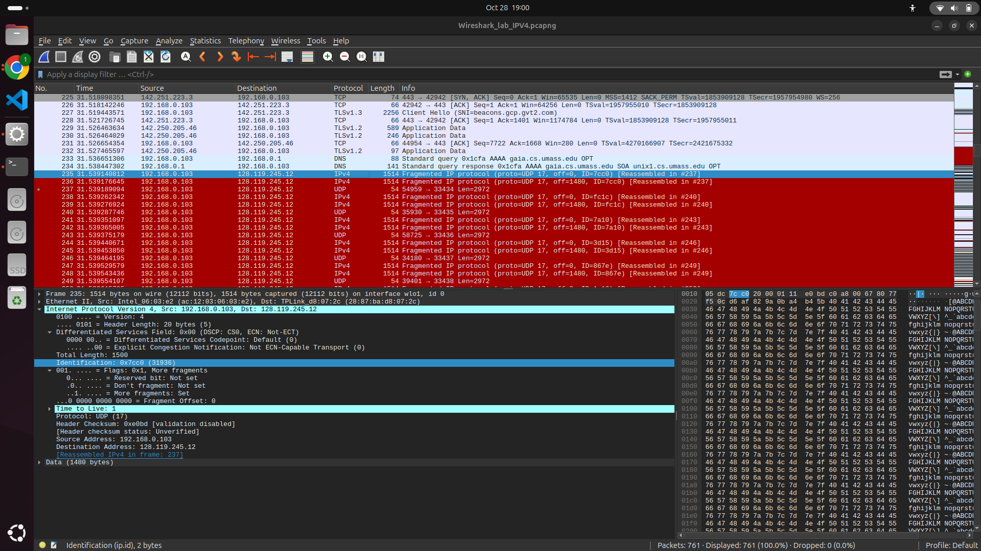
IP address of My Computer = 192.168.0.103
IP address of Destination (Website) = 128.119.245.12

Ans - When we send datagram of size 56

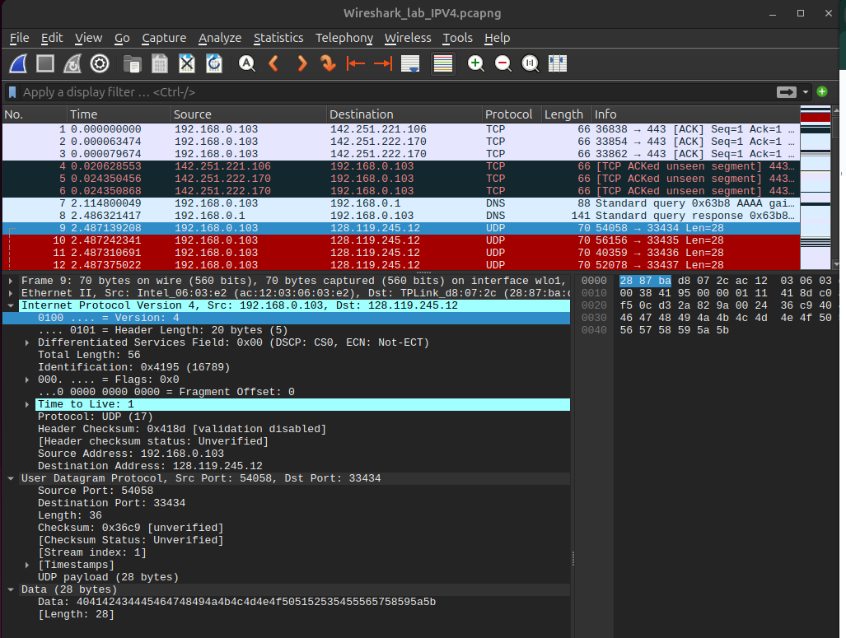

TTL Value = 1 (As its first datagram) – same for both cases of datagram size =56 and 3000
Traceroute sends a datagram by incrementing TTL values. It sends three probes with the same TTL value (As we can see three stars for each Hop in terminal Output).
- TTL=1 Three Probes
- TTL=2 Three Probes (After getting ICMP response message for First one)
- TTL=3 Three Probes (After getting ICMP response message for Second one)
And keep sending until an ICMP Echo Reply (or Port Unreachable) is received from the destination host.

Ans –

For datagrams of size 56 and 3000 we are getting the same Upper layer protocol.
Protocol UDP: 17
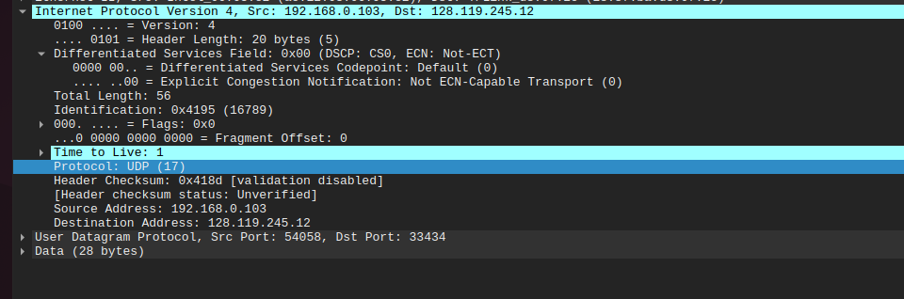

Ans-
When we send datagrams of size 56-
Total Length: 56
IP Header Length: 20
Payload = Total Length − IP Header Length
= 56 − 20
= 36 bytes
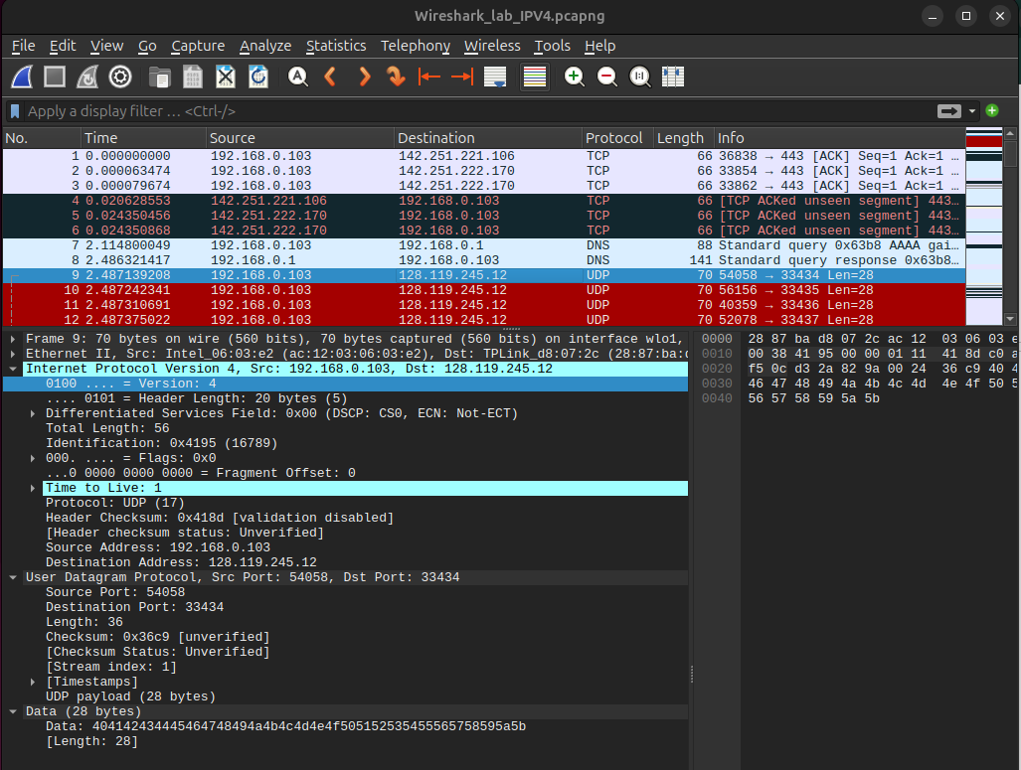

When we send datagrams of size 3000-
Total Length: 1500
IP Header Length: 20
Payload = Total Length − IP Header Length
= 1500 − 20
= 1480 bytes

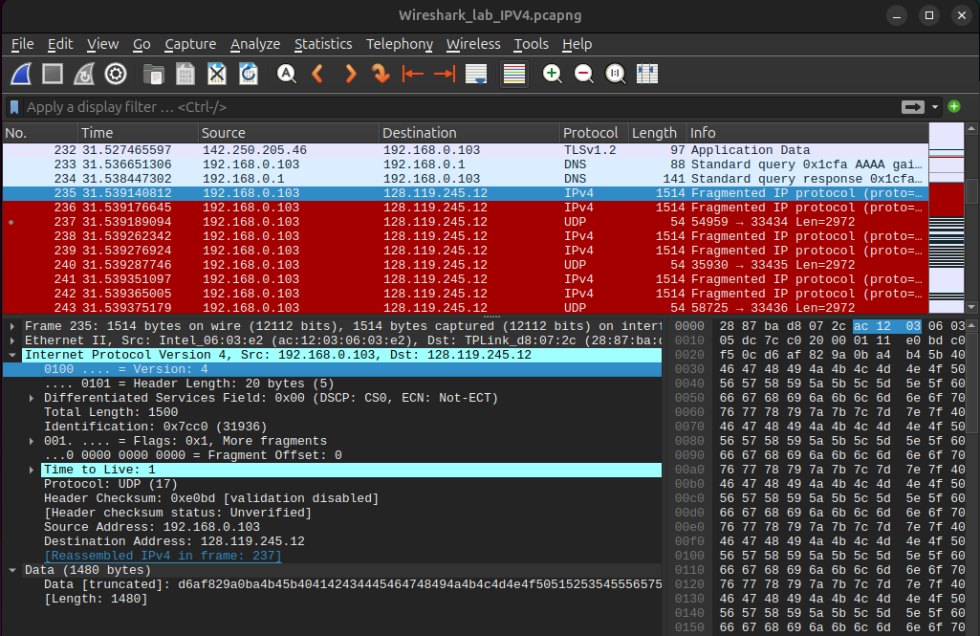

Ans -
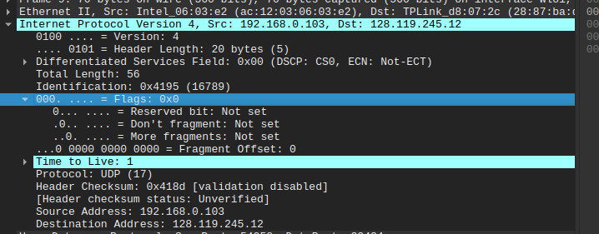
When we send datagrams of size 56 -
No, this datagram is not Fragmented
As we can see Flags: 0x0 suggests that no fragmentation
More Fragments= Not set, so there are no additional fragments.

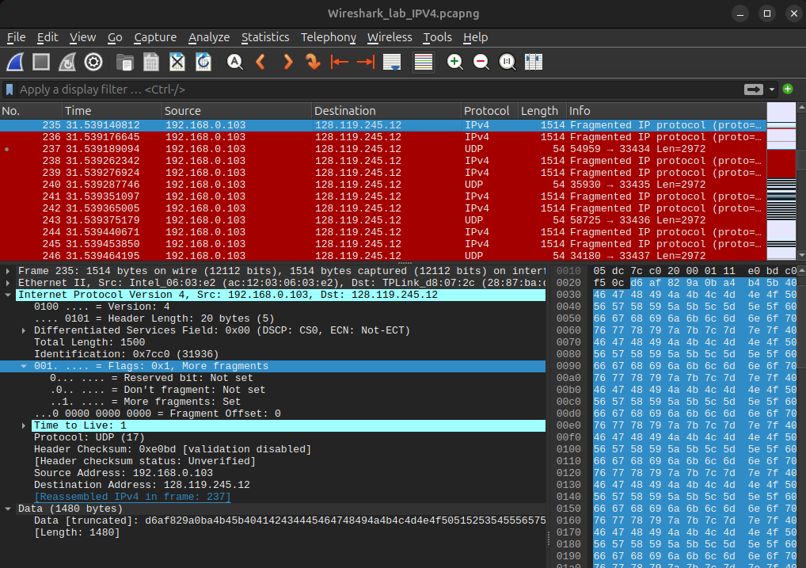

When we send datagrams of size 3000-
Yes, as the size of the datagram is 3000, it gets fragmented in two fragments and reassembled.
Flags Field Shows Flags: 0x1 More fragments
More Fragment: set <- means there are more fragments further.

Ans -
Datagram 1 - Probe -1
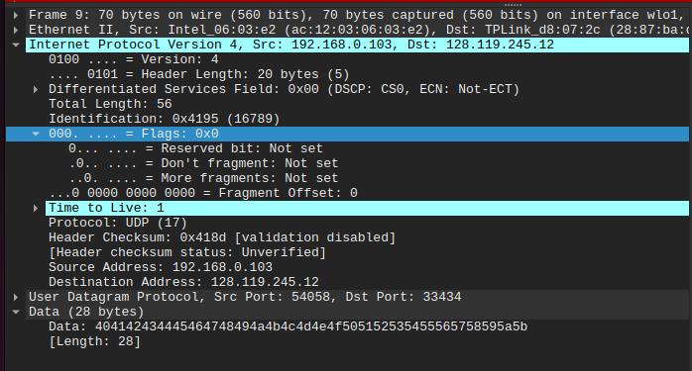
Datagram 1 - Probe -2
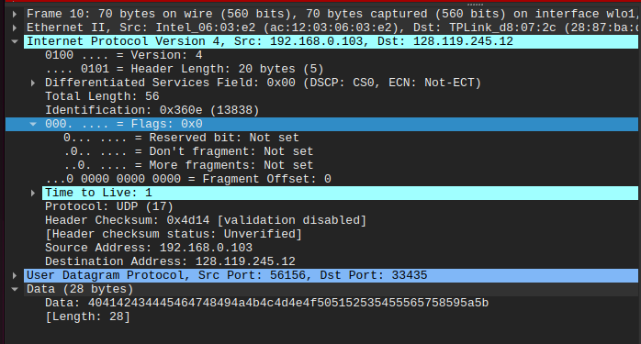
Datagram 2 - Probe -1
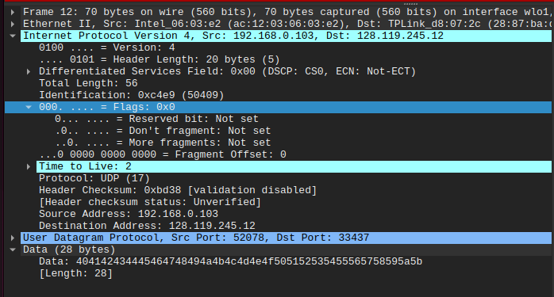

When we are sending datagram of Size 56
Frame | TTL | Datagram no. | Identification | Header Checksum
9 | 1 (Probe -1) | 1 | 0x4195 (16789) | 0x418d
10 | 1 (Probe -2) | 1 | 0x360e (13838) | 0x4d14
11 | 1 (Probe -3) | 1 | 0x4037 (16439) | 0x42eb
12 | 2 (Probe -1) | 2 | 0xc4e9 (50409) | 0xbd38
13 | 2 (Probe -2) | 2 | 0x5f80 (24448) | 0x22a2
14 | 2 (Probe -3) | 2 | 0x5410 (21520) | 0x2e12
15 | 3 (Probe -1) | 3 | 0xc2c5 (49861) | 0xbe5c
16 | 3 (Probe -2) | 3 | 0x05c8 (1480) | 0x7b5a
17 | 3 (Probe -3) | 3 | 0xd90b (55563) | 0xa816

3 Fields are observed to get change every time -
- Identification: this field gets changed because each datagram (Probe) gets a unique Identification Number.
- Header Checksum: This is calculated using all fields of IP header as TTL and Identification getting changed we will get different values for header checksum.
- TTL: Traceroute sends 3 Probes with the same TTL value. There Will be three datagrams with same TTL value.

When we are sending datagram of size 3000
TTL | Datagram no. | Frag. No. | Identification | Header Checksum
1 (Probe -1) | 1 | 1 | 0x7cc0 (31936) | 0xe0bd
1 (Probe -1) | 1 | 2 | 0x7cc0 (31936) | 0xe004
1 (Probe -2) | 1 | 1 | 0xfc1c (64540) | 0x6161
1 (Probe -2) | 1 | 2 | 0xfc1c (64540) | 0x60a8
1 (Probe -3) | 1 | 1 | 0x7a10 (31248) | 0xe36d
1 (Probe -3) | 1 | 2 | 0x7a10 (31248) | 0xe2b4
2 (Probe -1) | 2 | 1 | 0x3d15 (15637) | 0x1f69
2 (Probe -1) | 2 | 2 | 0x3d15 (15637) | 0x1eb0
2 (Probe -2) | 2 | 1 | 0x867e (34430) | 0xd5ff
2 (Probe -2) | 2 | 2 | 0x867e (34430) | 0xd546
2 (Probe -3) | 2 | 1 | 0x1a16 (6678) | 0x4268
2 (Probe -3) | 2 | 2 | 0x1a16 (6678) | 0x41af

3 Fields are observed to get change every time -
- Identification: this field gets changed because each datagram gets a unique Identification Number. As in this case Fragmentation is happening, so for each fragment the same datagram will have the same identification number.
- Header Checksum: This is calculated using all fields of IP header as TTL and Identification getting changed we will get different values for header checksum.
- TTL: TTL Value will be different for each datagram. With the same TTL value we are sending three probes so each probe belonging to the same datagram will have the same TTL. As in this case Fragmentation is happening, so for each fragments the TTL value will be also the same.

Ans -
Case - 1 When traceroute is sending datagram of size 56 Bytes.
The fields which remain constant are
- Source IP Address As all packets sent from same Client
- Destination IP Address Traceroute is sent to same destination Server.
- Protocol and version because the same transport protocol and version is used for all packets
- UDP Payload size Each datagram is carrying same payload.
- Flags field size
- IP Header Length As traceroute are sending similar kind of datagram. Header fields remain same, and Header length remains constant.
- Differentiated Services Field = 0x00 because no QoS or congestion control difference between packets.

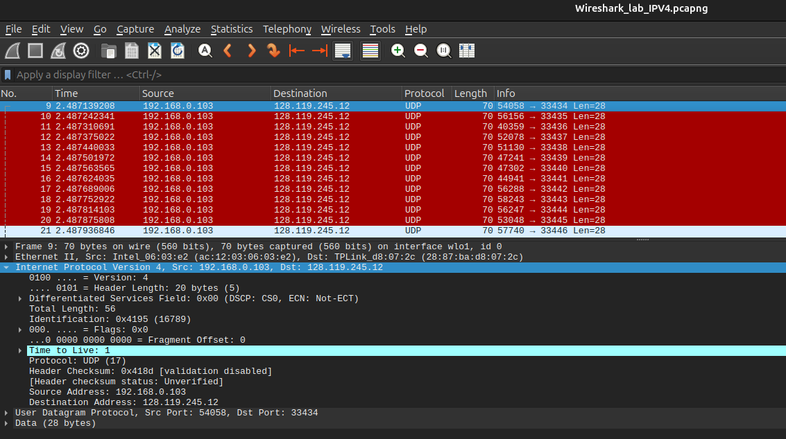

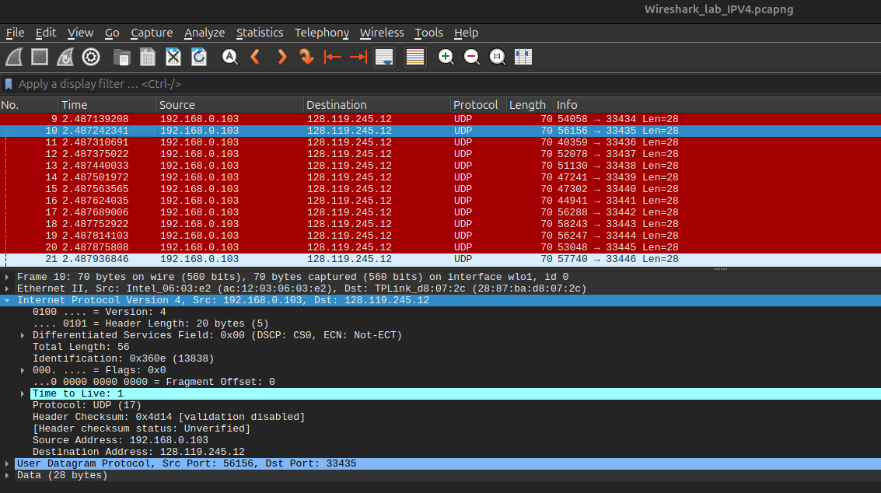
Case - 2 When traceroute is sending datagram of size 3000 Bytes
The fields which remain constant are
- Source IP Address As all packets sent from same Client
- Destination IP Address Traceroute is sent to the same destination Server.
- Protocol and Version because the same transport protocol and version is used for all packets.
- IP Header Length As traceroute are sending a similar kind of datagram. Header fields remain the same and Header length remains constant.
- Differentiated Services Field = 0x00 because no QoS or congestion control difference between packets.

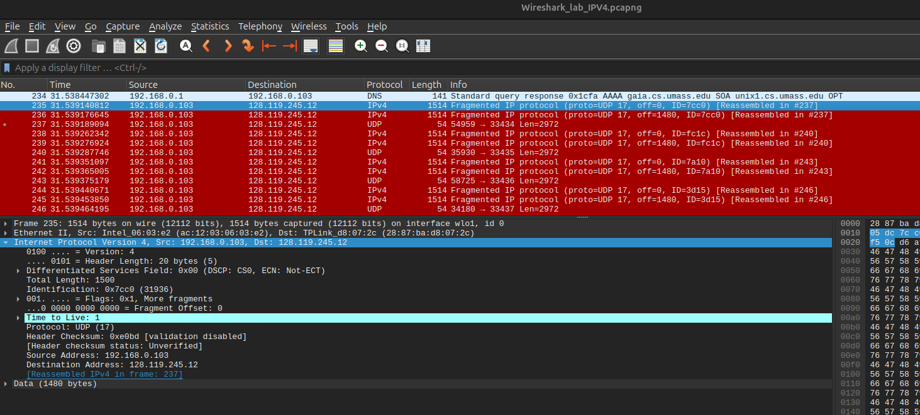
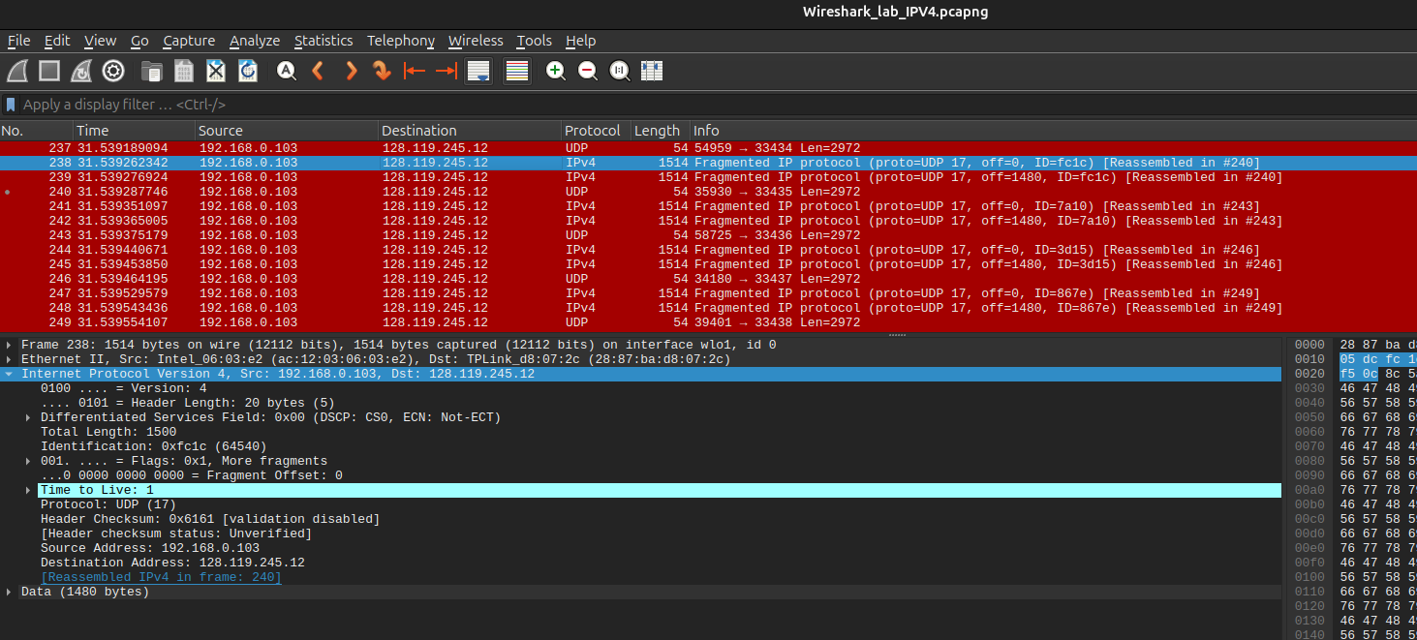

Ans-

When we are sending datagram of size = 56 Bytes
In this case no fragmentation occurs so we are sending 3 probes with the same TTL Value.
For each probe of any TTL value we get a different Identification number.

TTL | Datagram no. | Identification
1 (Probe -1) | 1 | 0x4195 (16789)
1 (Probe -2) | 1 | 0x360e (13838)
1 (Probe -3) | 1 | 0x4037 (16439)
2 (Probe -1) | 2 | 0xc4e9 (50409)
2 (Probe -2) | 2 | 0x5f80 (24448)
2 (Probe -3) | 2 | 0x5410 (21520)
3 (Probe -1) | 3 | 0xc2c5 (49861)
3 (Probe -2) | 3 | 0x05c8 (1480)
3 (Probe -3) | 3 | 0xd90b (55563)

When we are sending datagram of size =3000 Bytes
In this case there is fragmentation so for each fragment belonging each datagram will have the same Identification value.
For all datagrams with any TTL value have a unique Identification value.

TTL | Datagram no. | Frag. No. | Identification
1 (Probe -1) | 1 | 1 | 0x7cc0 (31936)
1 (Probe -1) | 1 | 2 | 0x7cc0 (31936)
1 (Probe -2) | 1 | 1 | 0xfc1c (64540)
1 (Probe -2) | 1 | 2 | 0xfc1c (64540)
1 (Probe -3) | 1 | 1 | 0x7a10 (31248)
1 (Probe -3) | 1 | 2 | 0x7a10 (31248)
2 (Probe -1) | 2 | 1 | 0x3d15 (15637)
2 (Probe -1) | 2 | 2 | 0x3d15 (15637)
2 (Probe -2) | 2 | 1 | 0x867e (34430)
2 (Probe -2) | 2 | 2 | 0x867e (34430)
2 (Probe -3) | 2 | 1 | 0x1a16 (6678)
2 (Probe -3) | 2 | 2 | 0x1a16 (6678)

Ans -
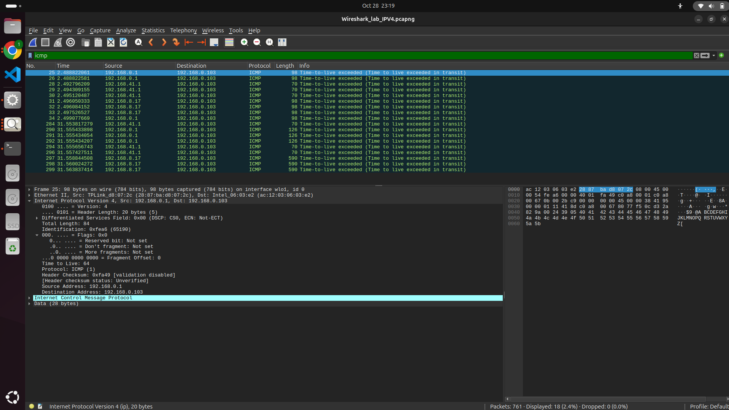
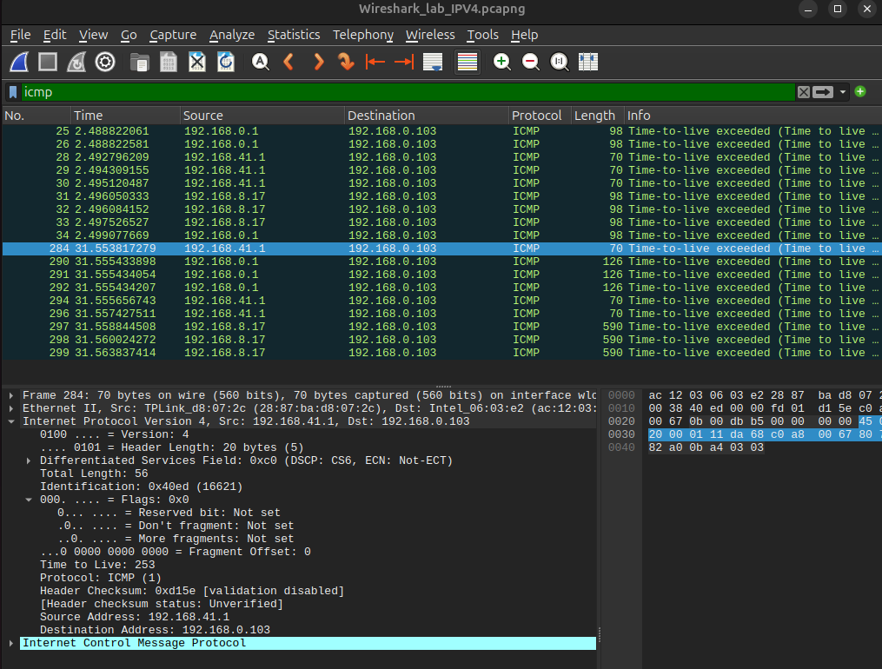
Out of 30 Hops only 3 Hops have replied with ICMP TTL Exceeded Message.
I got IP datagram from router with IP Address
- 192.168.0.1
- 192.168.41.1
- 192.168.8.17
Got 3 Replies from each of these routers as traceroute have sent 3 probes with the same TTL value.
ICMP message my PC received from router has Upper layer protocol -
Protocol: ICMP (1)

Ans -

I got a total of 30 Hops for Traceroute. Out of which only 3 routers reply with ICMP TTL Exceeded Message.
As some ISP or Router are configured to drop or Ignore the TTL Exceeded or expire message i got reply from only 3 routers out of 30 Router.

I got IP datagram from router with IP Address
- 192.168.0.1
- 192.168.41.1
- 192.168.8.17
Got 3 Replies from each of these routers as traceroute have sent 3 probes with the same TTL value.
When we are using Datagram of size 56 Bytes

Frame No. | Router IP Address | Identification Field
25 | 192.168.0.1 | 0xfea6
26 | 192.168.0.1 | 0xfea7
28 | 192.168.41.1 | 0x3a47
29 | 192.168.41.1 | 0x3a48
30 | 192.168.41.1 | 0x3a49
31 | 192.168.8.17 | 0x2669
32 | 192.168.8.17 | 0x266a
33 | 192.168.8.17 | 0x266b
34 | 192.168.0.1 | 0xfea8

Observation -
- For Each reply from the same router, Identification value gets incremented by 1.
- As we have sent 3 Probe with the same TTL Value we get 3 replies from each router (Who has sent a reply).
- For ex- Router with IP - 192.168.41.1 Sent reply for First 0x3a47 -> second 0x3a48 -> Third 0x3a49

When we are using Datagram of Size 3000 Bytes

Frame No. | Router IP Address | Identification Field
284 | 192.168.41.1 | 0x40ed
290 | 192.168.0.1 | 0xfea3
291 | 192.168.0.1 | 0xfea4
292 | 192.168.0.1 | 0xfea5
294 | 192.168.41.1 | 0x40ee
296 | 192.168.41.1 | 0x40ef
297 | 192.168.8.17 | 0x2ae0
298 | 192.168.8.17 | 0x2ae1
299 | 192.168.8.17 | 0x2ae2

Observation -
- In this case fragmentation occurred, still we get single reply for each datagram sent.
- As we have sent 3 Probe with the same TTL Value we get 3 replies from each router(Who has sent a reply).
- For ex- Router with IP - 192.168.41.1 Sent reply for First 0x40ed -> second 0x40ee -> Third 0x40ef

Ans -
When we are using Datagram of size 56 Bytes

Frame No. | Router IP Address | TTL
25 | 192.168.0.1 | 64
26 | 192.168.0.1 | 64
28 | 192.168.41.1 | 253
29 | 192.168.41.1 | 253
30 | 192.168.41.1 | 253
31 | 192.168.8.17 | 252
32 | 192.168.8.17 | 252
33 | 192.168.8.17 | 252
34 | 192.168.0.1 | 64

When we are using Datagram of Size 3000 Bytes

Frame No. | Router IP Address | TTL
284 | 192.168.41.1 | 253
290 | 192.168.0.1 | 64
291 | 192.168.0.1 | 64
292 | 192.168.0.1 | 64
294 | 192.168.41.1 | 253
296 | 192.168.41.1 | 253
297 | 192.168.8.17 | 252
298 | 192.168.8.17 | 252
299 | 192.168.8.17 | 252

Observation -
- TTL values corresponding to the same router have the same Value.
- TTL value for reply of those datagrams which have same TTL value also same TTL value

Part -2 Fragmentation (Question numbering is as per the document provided)

13.
Ans –

When i my PC sent segment with length 3000 Bytes-
As MTU (maximum Transmission Unit is 1480) our segment gets fragmented into three fragments.

Yess, our segment has fragmented into fragments.

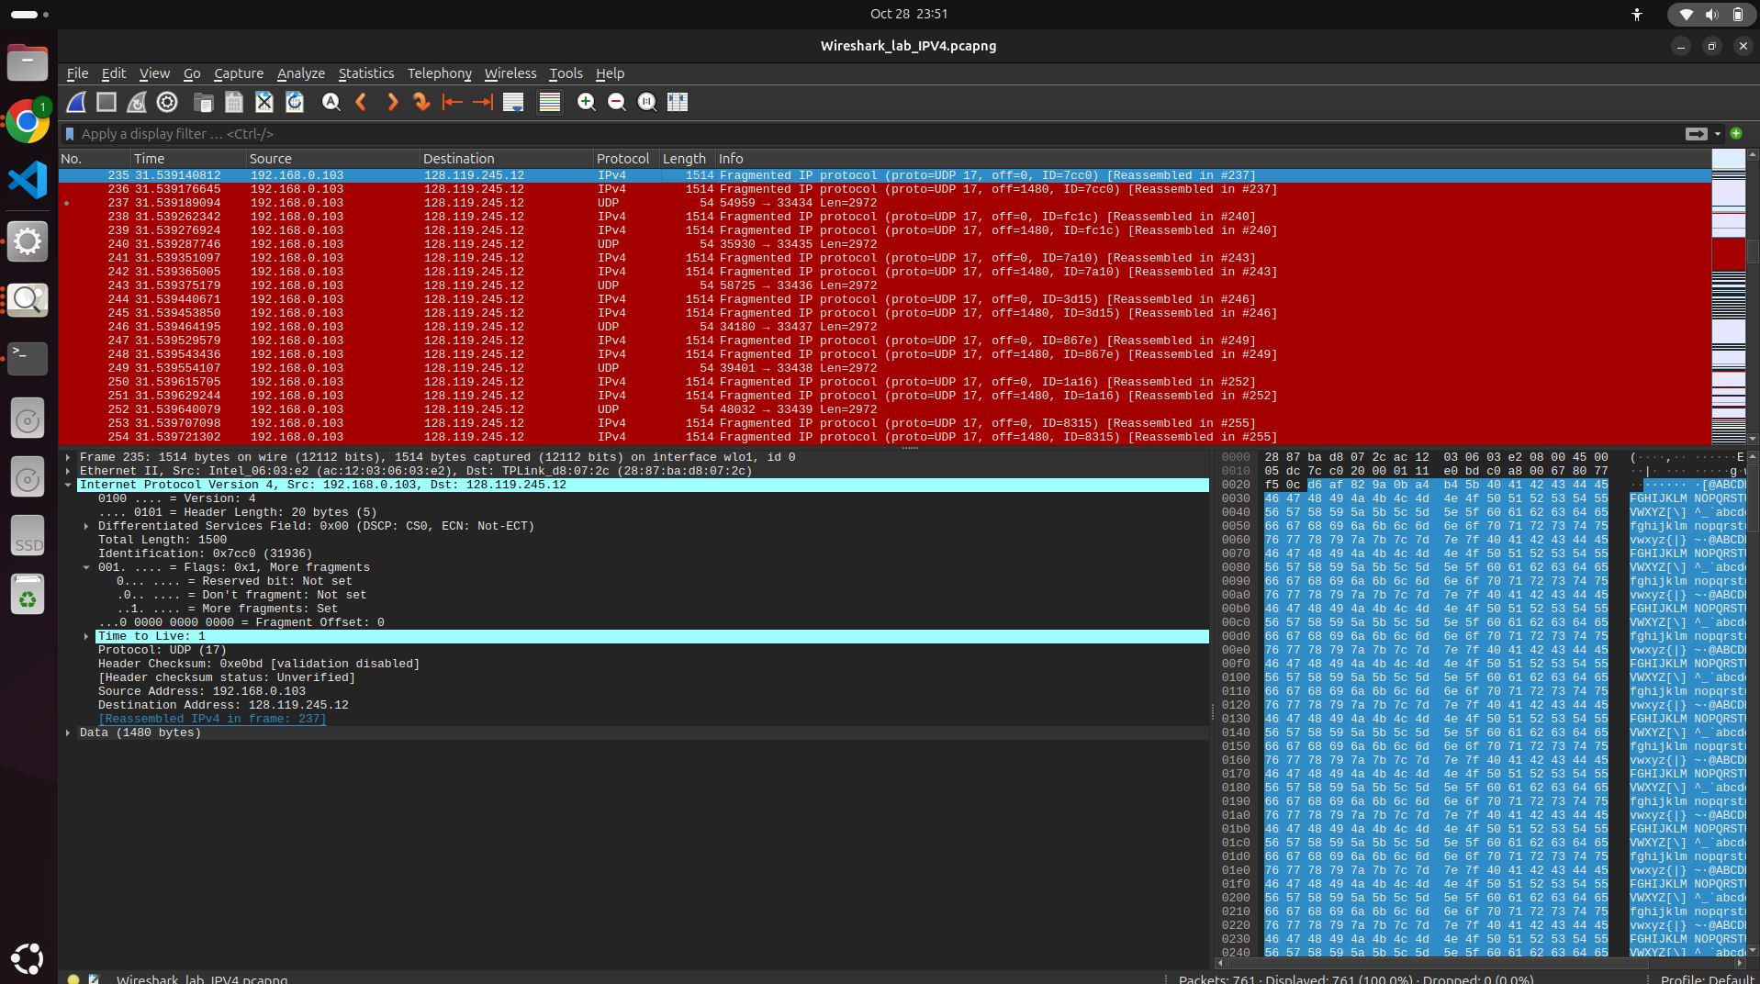

As we can see in capture, our segment got fragmented as Packet 235,236 and 237 and got reassembled at 237.
In the Flags Field in the packet it shows that: Flags : 0x1 More fragments.

14.
Ans -
As we can see our packet gets fragmented into two fragments 235,236 and 237.
In packet 235-
In IPV4 header-
We can see Flags : 0x1 More Fragments <- suggest that there are more fragments.
The Field More fragments : set Suggest there are more fragments.

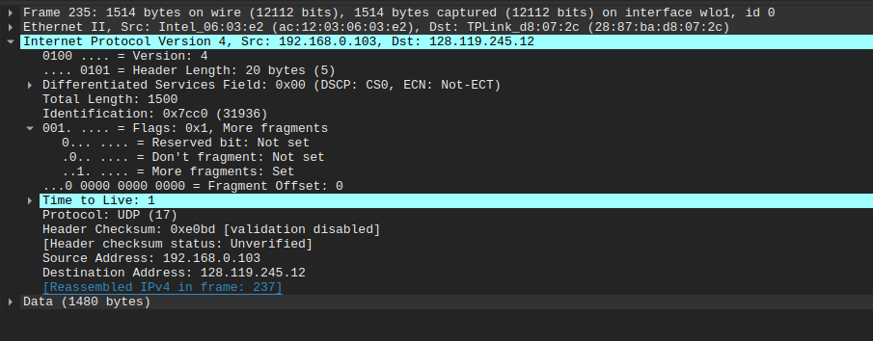

15.
Ans -
In packet 235-
In IPV4 header-
We can see Flags : 0x1 More Fragments <- suggest that there are more fragments.
The Field More fragments : set Suggest there are more fragments.
Fragments Offset : 0 <- suggest that this is the first fragment of datagram.



16.
Ans -
In packet 236-
In IPV4 header-
We can see Flags : 0x1 More Fragments <- suggest that there are more fragments.
The Field More fragments : set Suggest there are more fragments.
Fragments Offset : 1480 <- Suggest this fragment starts from 1480 B of original Datagram. Non Zero value of Fragmentation offset suggests that this fragment is not first fragment.
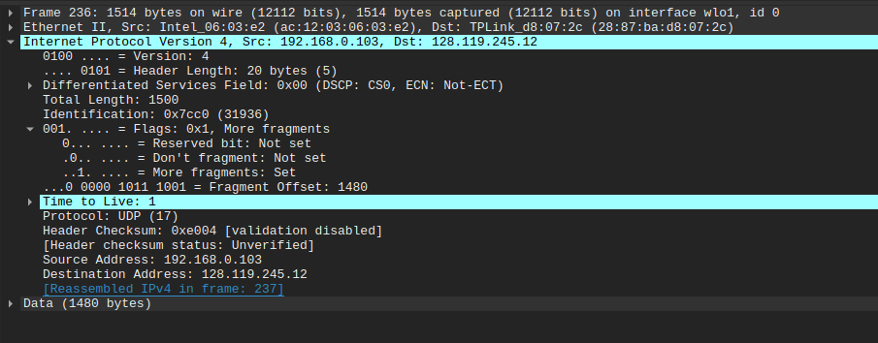

17.
Ans-
In packet 237-
In IPV4 header-
We can see Flags : 0x0 No more fragments <- suggest that there are no more fragments.
The Field More fragments : Not set Suggest this is the last fragment.
Frag offset is 2960 means it contains last 40 Bytes
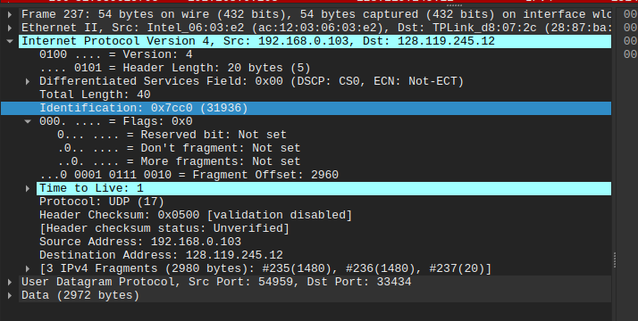

Part - B Wireshark Lab: NAT

(As per instructions I am using the author's provided PCAP File.)

Ans -

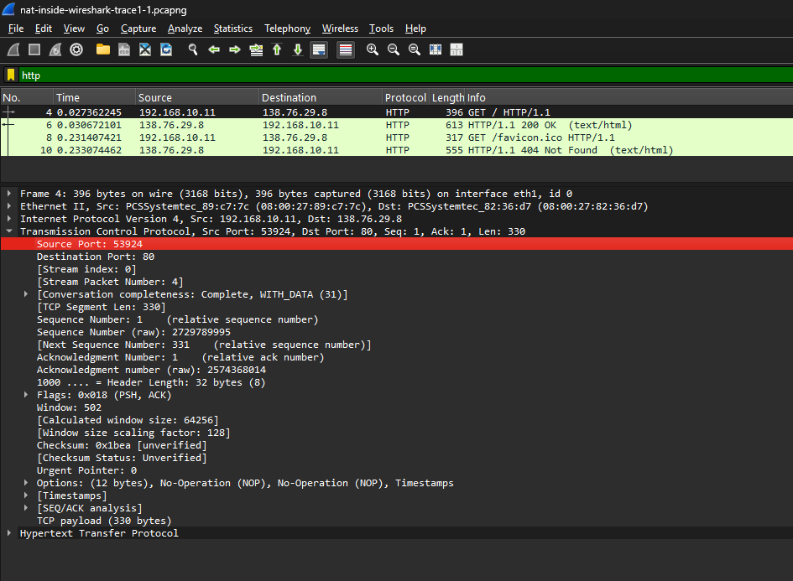
Details for HTTP GET Message -
IP Address of Source - 192.168.10.11 (Client)
IP Address of Destination - 138.76.29.8 (Server)
Source Port Number - 53924
Destination Port Number - 80

Ans-
Time At which Client Sends GET Request - 0.027362245 sec
Time At which Client Receives Response - 0.030672101 sec

Ans -
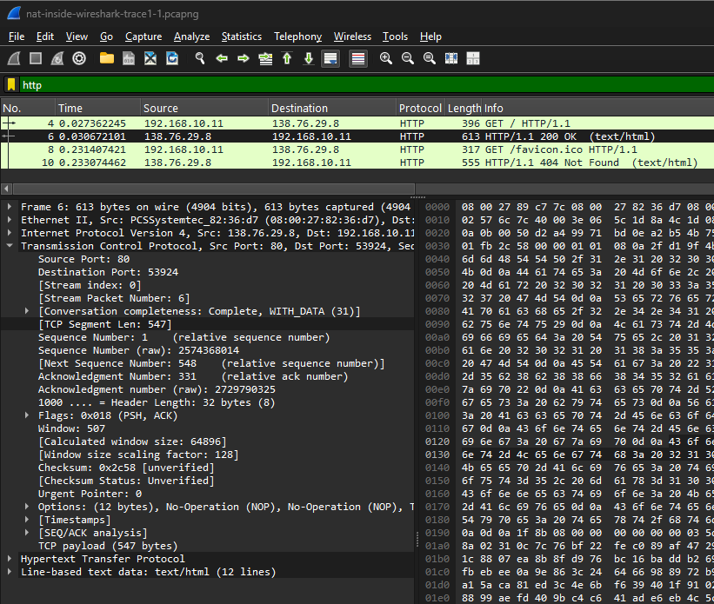
Details for Response HTTP Message -
Source IP address: 138.76.29.8
Destination IP address: 192.168.10.11
TCP Source Port: 80
TCP Destination Port: 53924

Ans -
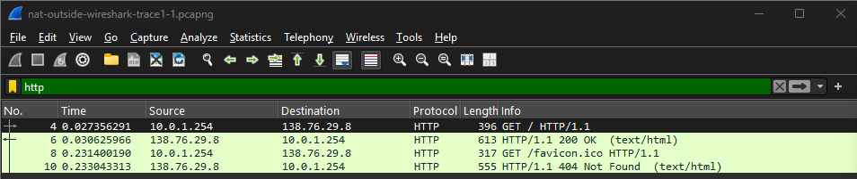
Time at Which HTTP GET Message appear - 0.027356291 sec

Ans-
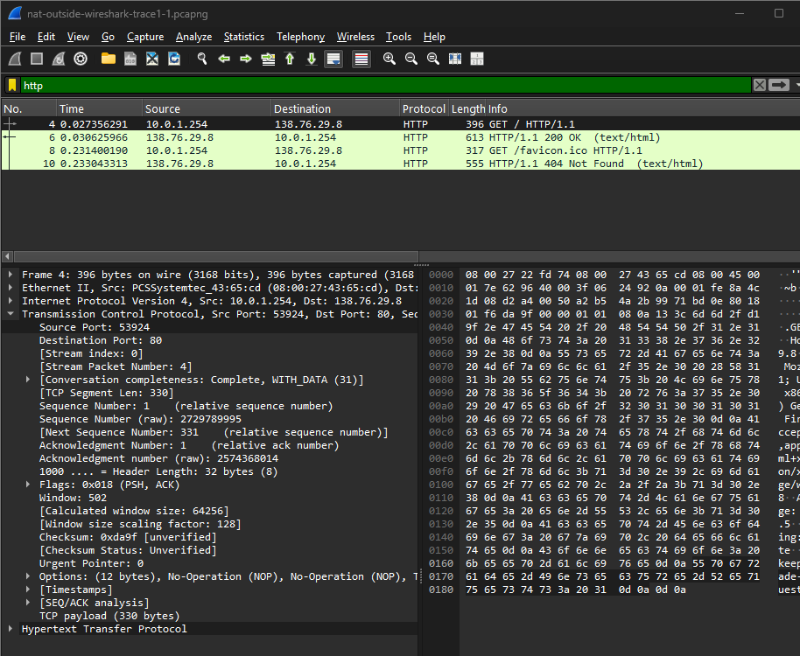
Source IP address: 10.0.1.254
Destination IP address: 138.76.29.8
TCP Source Port: 53924
TCP Destination Port: 80

Ans -
Changed Fields - Source ip from 192.168.10.11 >>> 10.0.1.254
Remaining Fields - Remains Unchanged Destination IP and Source IP.
Apart from this Fields following fields get changed for HTTP GET in both Inside and outside of LAN-
Header checksum
0x64dc -> 0x2492

Source MAC:
08:00:27:89:c7:7c → 08:00:27:43:65:cd

Destination MAC:
08:00:27:82:36:d7 (PCSSystemtec_82:36:d7) -> 08:00:27:22:fd:74

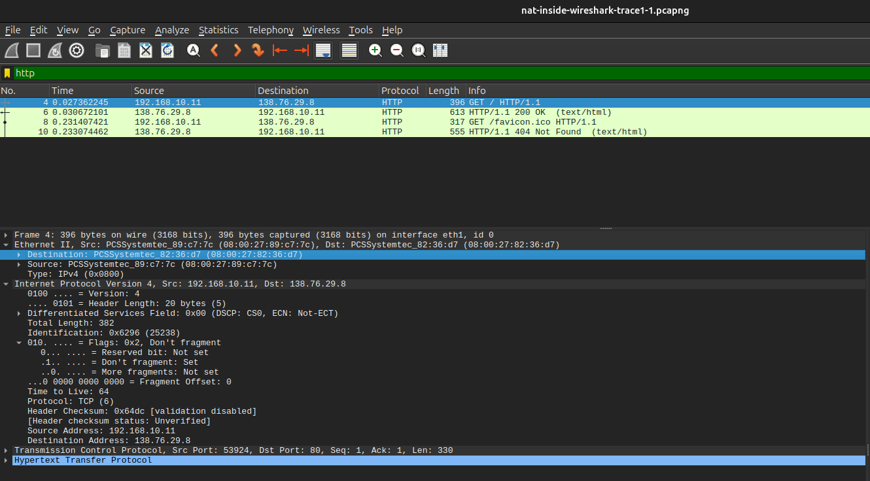
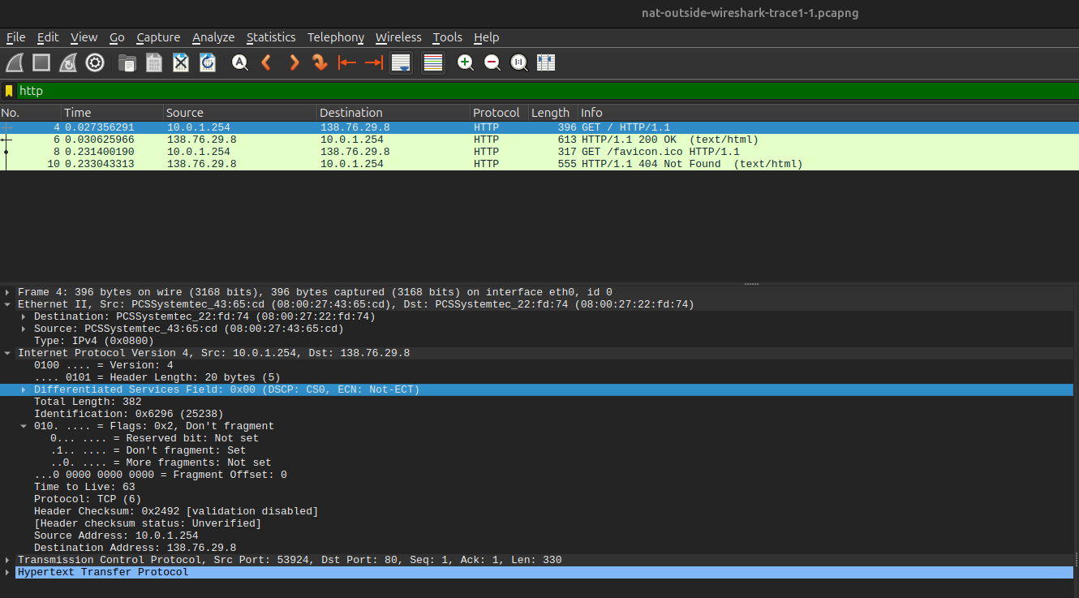

Ans -
Only Header Checksum is Observed to get changed, in IP datagram carrying the HTTP GET received on LAN (Inside) to the corresponding datagram when forwarded on internet side of of Network address Translation

 | LAN (Inside) | LAN (Outside)
Version | Version: 4 | Version: 4
Header Length | Header Length: 20 bytes (5) | Header Length: 20 bytes (5)
Flags | Flags: 0x2 Don’t Fragment  Reserved bit: Not set  Don’t fragment: Set  More fragments: Not set | Flags: 0x2 Don’t Fragment  Reserved bit: Not set  Don’t fragment: Set  More fragments: Not set
Checksum | Header Checksum: 0x64dc | Header Checksum: 0x2492

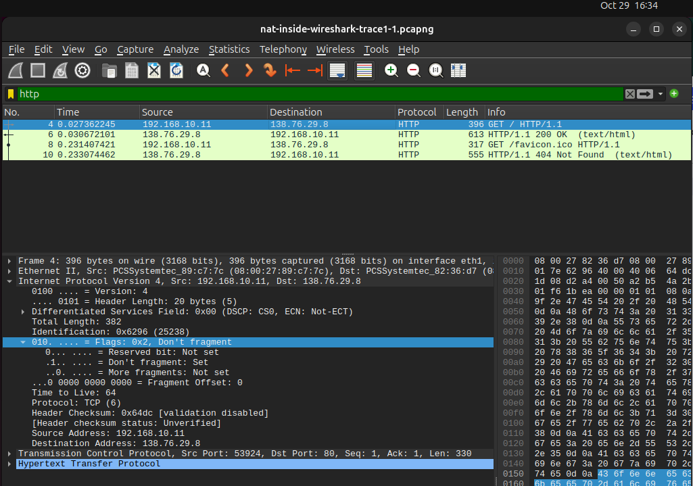
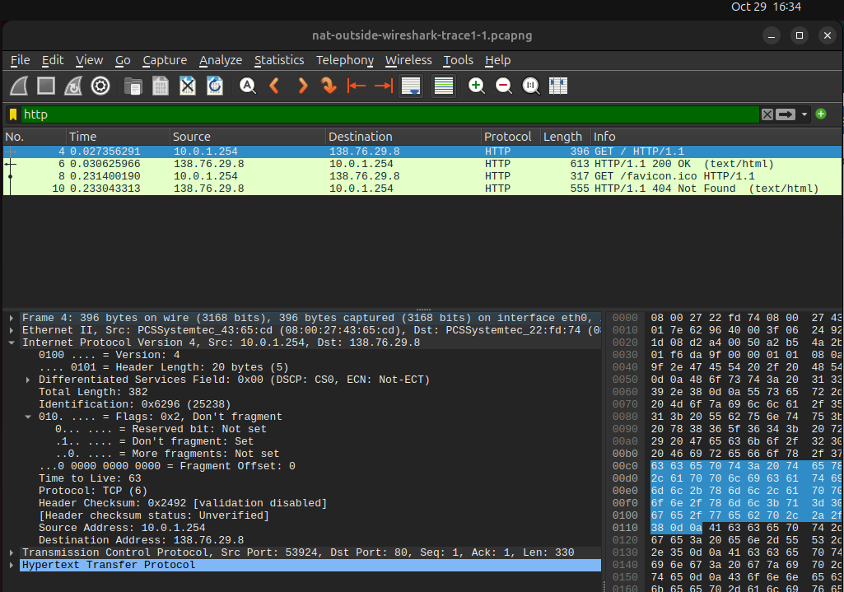

Ans - In nat-outside-wireshark-trace1-1.pcapng trace file -
HTTP GET message appear at - 0.027356291 sec
HTTP OK Message appear at - 0.030625966 sec
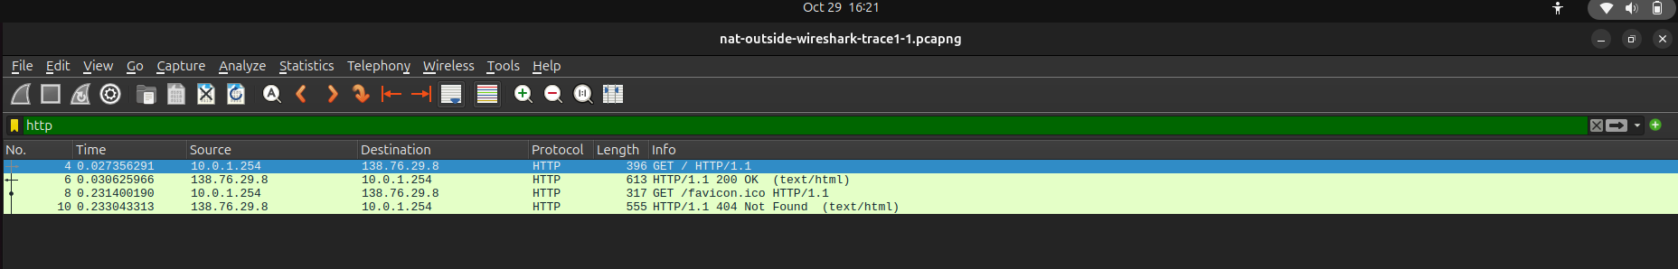

Ans -
For HTTP reply (“200 OK”) -
Source IP address: 138.76.29.8
Destination IP address: 10.0.1.254
TCP Source Port: 80
TCP Destination Port: 53924
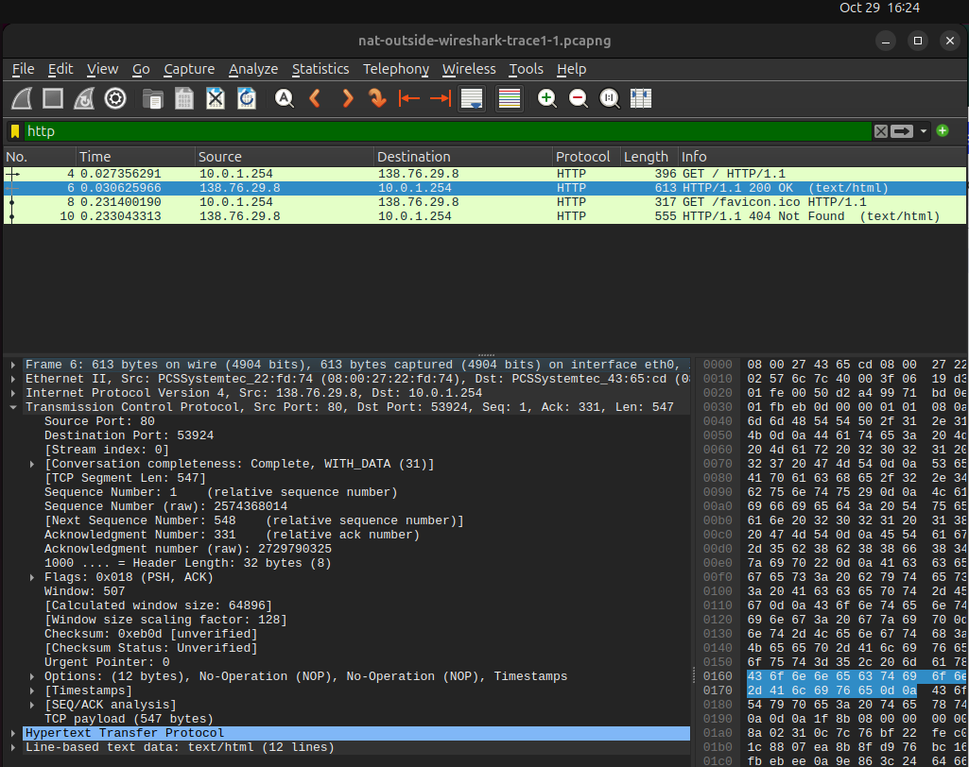

Ans -
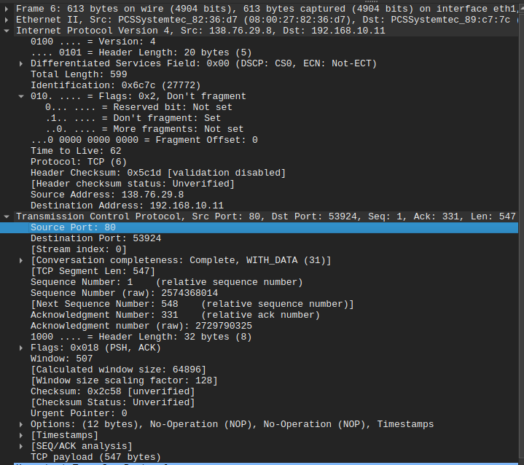

Source IP address: 138.76.29.8 (Router)
Destination IP address: 192.168.10.11 (Destination Host)
TCP Source Port: 80
TCP Destination Port: 53924

Part C- Wireshark Lab: DHCP

Ans -
Packet 7 Shows DHCP Discover Message -
In IPV4 header Entries we can see - Protocol UDP (17)
In the User Datagram Protocol Header we can see - Source Port -68 and Destination Port-67 which are standard for UDP Protocol.
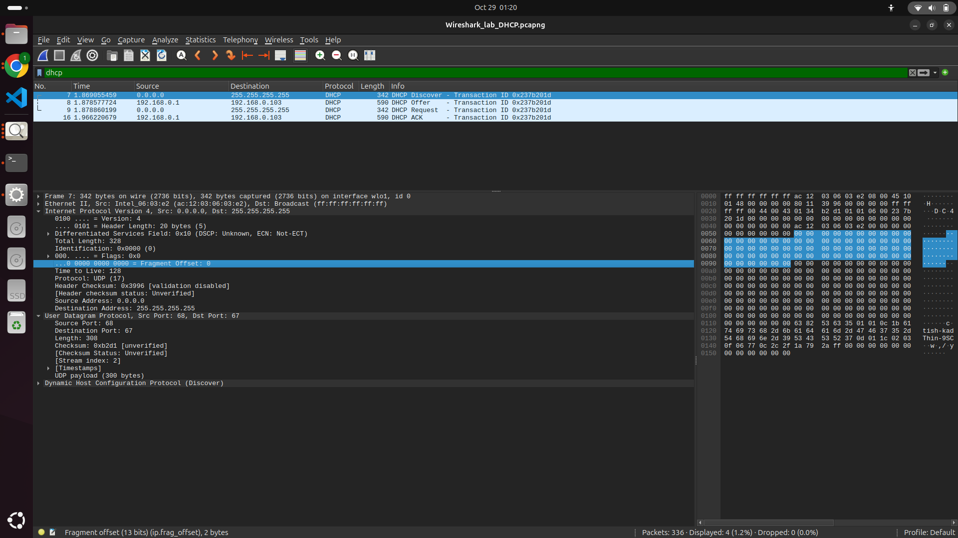

Ans - Source IP Address : 0.0.0.0
Reason - “Any DHCP Server Out there ?”
Source (Client) has No IP Address so client uses this IP.
As the client wants to find a DHCP Server, it is using a dummy address for source and send the packet to the broadcast address.
Now,DHCP server on the local network can respond.
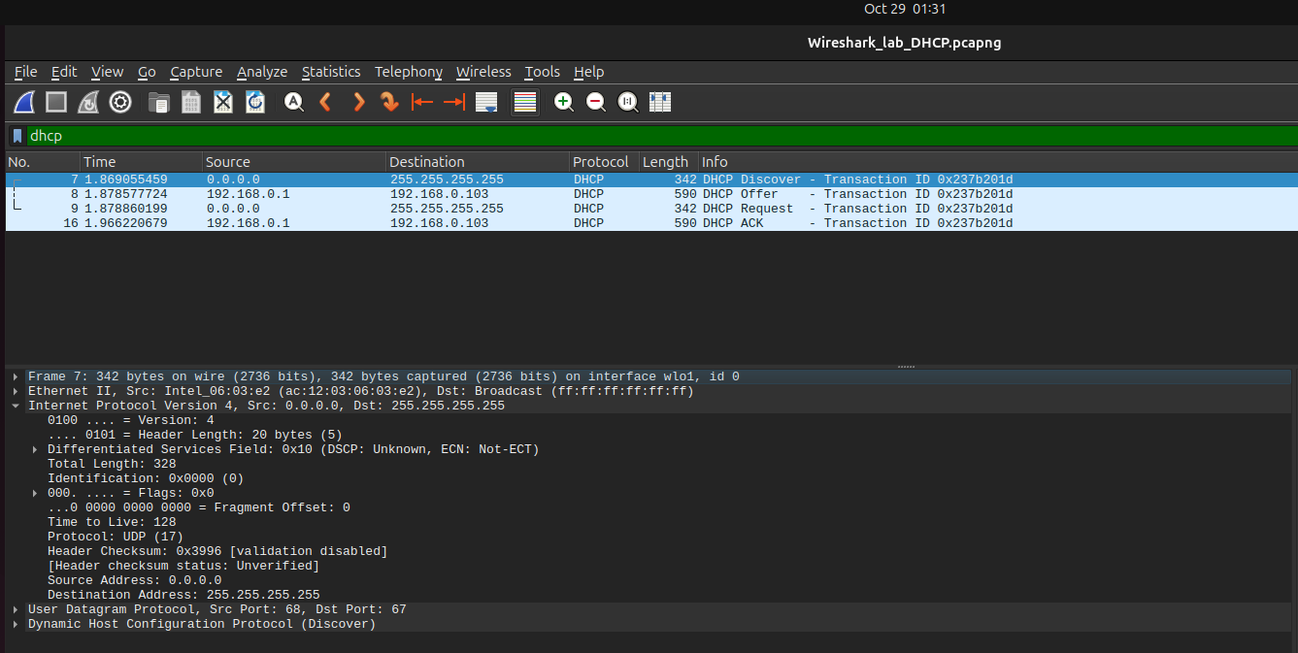

Ans -
Destination IP Address : 255.255.255.255
Reason : It is a limited broadcast address.
When we use this as Destination address then our discover message get sent to all hosts in the local subnet.
As we dont aware about IP address of server this message get received by all.



Ans -
As we observed in DHCP Section
Transaction ID - 0x237b201d
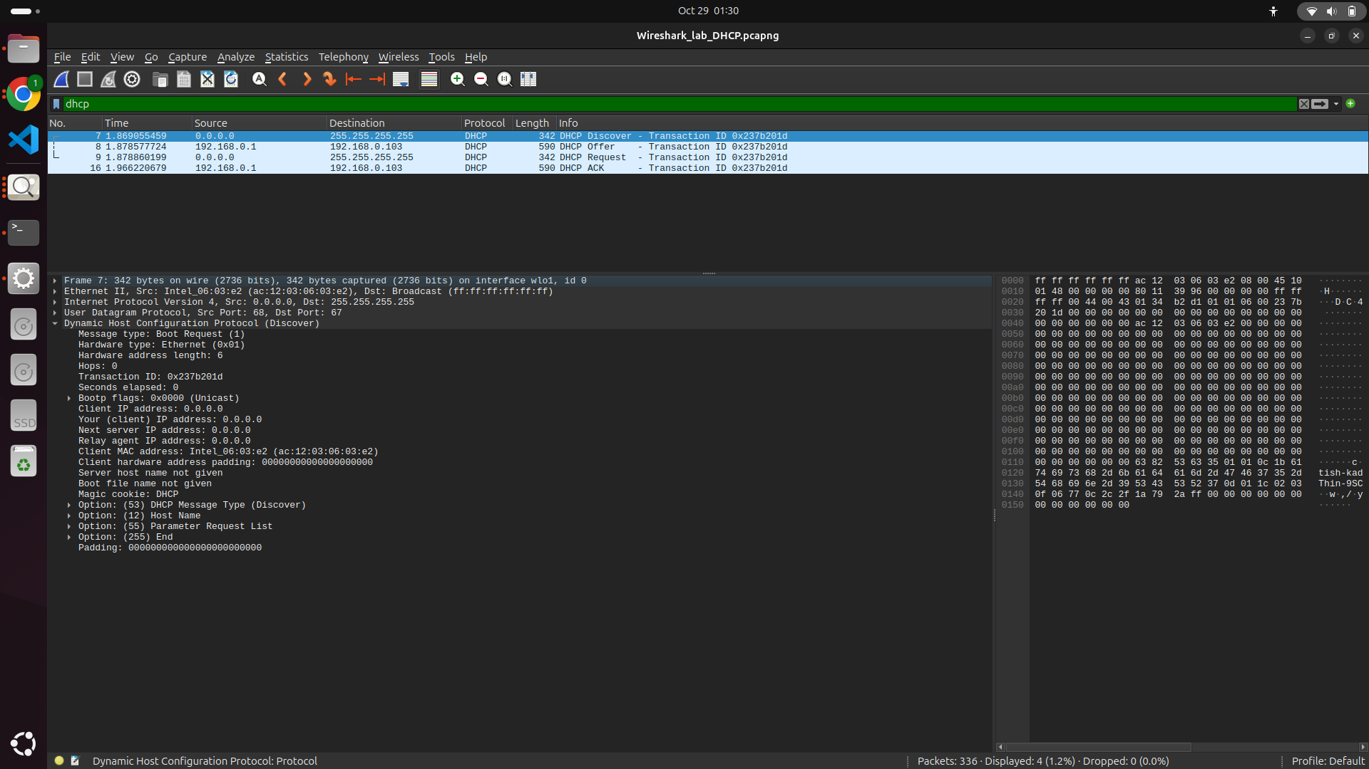

Ans -
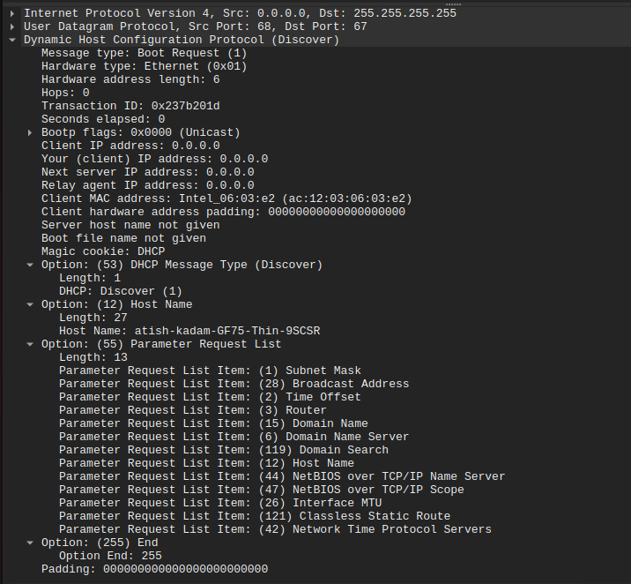
Option: (55) Parameter Request List:
(1) Subnet Mask
(28) Broadcast Address
(2) Time Offset
(3) Router
(15) Domain Name
(6) Domain Name Server
(119) Domain Search
(12) Host Name
(44) NetBIOS over TCP/IP Name Server
(47) NetBIOS over TCP/IP Scope
(26) Interface MTU
(121) Classless Static Route
(42) Network Time Protocol Servers

Ans -
- If we want to check whether the DHCP Offer belongs to which Discover message, we can check its transaction ID.
- Transaction ID is Always the same for Discover, Offer, Request and Ack Message.
- Here we can see the Transaction ID (0x237b201d) of the DHCP Offer message which is similar to the DHCP Discover message.

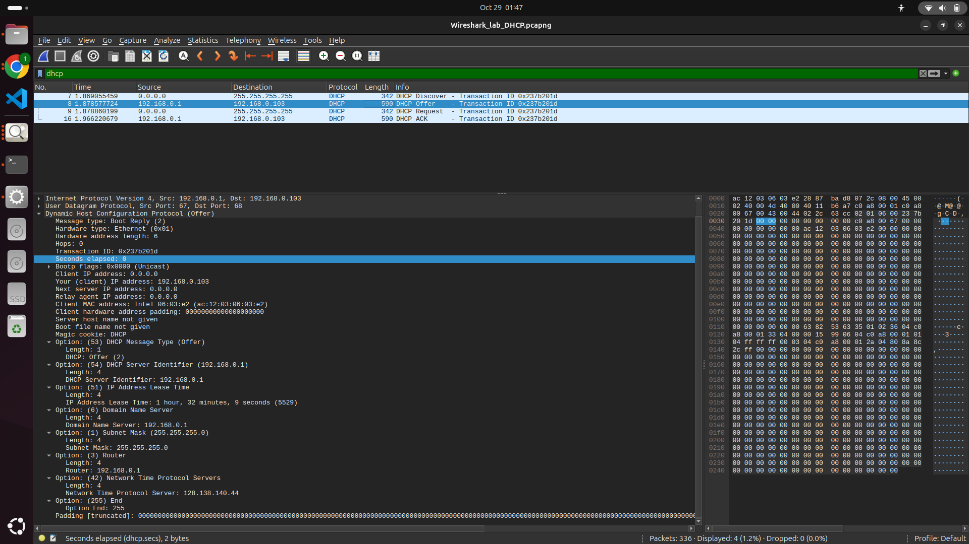

Ans -
- Source IP Address : 192.168.0.1 for DHCP Offer message.
- This IP Address belongs to Router (Local Networks DHCP Server).
- Use of this IP address to get know about DHCP Server that made the offer.
- It is important because it identifies the device providing the client with network setup parameters, such as IP address, subnet mask, router, and DNS information.
- The router serving as the network's DHCP server is represented by this address.
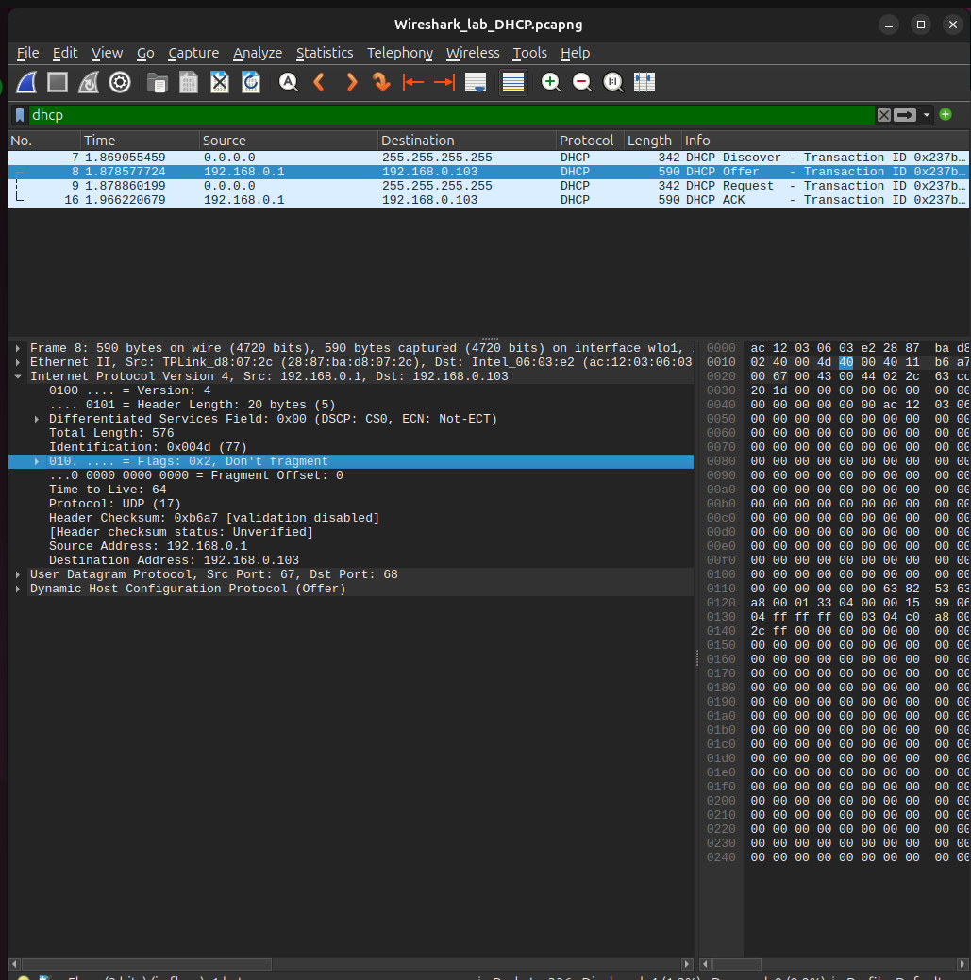

Ans -
Destination IP Address : 192.168.0.103
- This target IP for DHCP Offer.
- This address is offered to client by DHCP server.
- This IP address is NOT yet totally acquired by client. No configuration done yet.
- To let the client know which IP address it can use if accepted, the server includes this address in the Offer message.
- Even when the client does not yet have a valid IP address, communication is still possible because the message is usually conveyed using link-layer addressing, which is dependent on the client's MAC address.

Ans -
- Option: (54) DHCP Server Identifier — 192.168.0.1
- Option: (51) IP Address Lease Time — 1 hour, 32 minutes, 9 seconds (5529)
- Option: (6) Domain Name Server — 192.168.0.1 —
- Option: (1) Subnet Mask — 255.255.255.0
- Option: (3) Router — 192.168.0.1
- Option: (42) Network Time Protocol Servers — 128.138.140.44
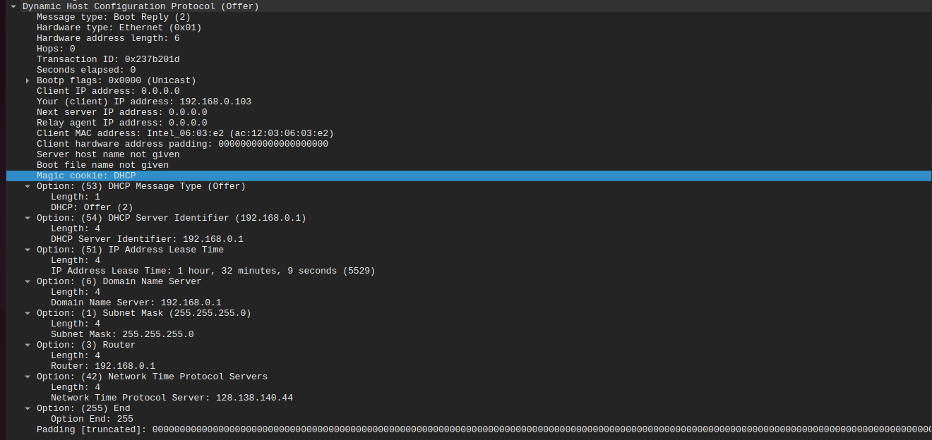

Ans -
UDP Source Port Number - 68
UDP Destination Port Number - 67
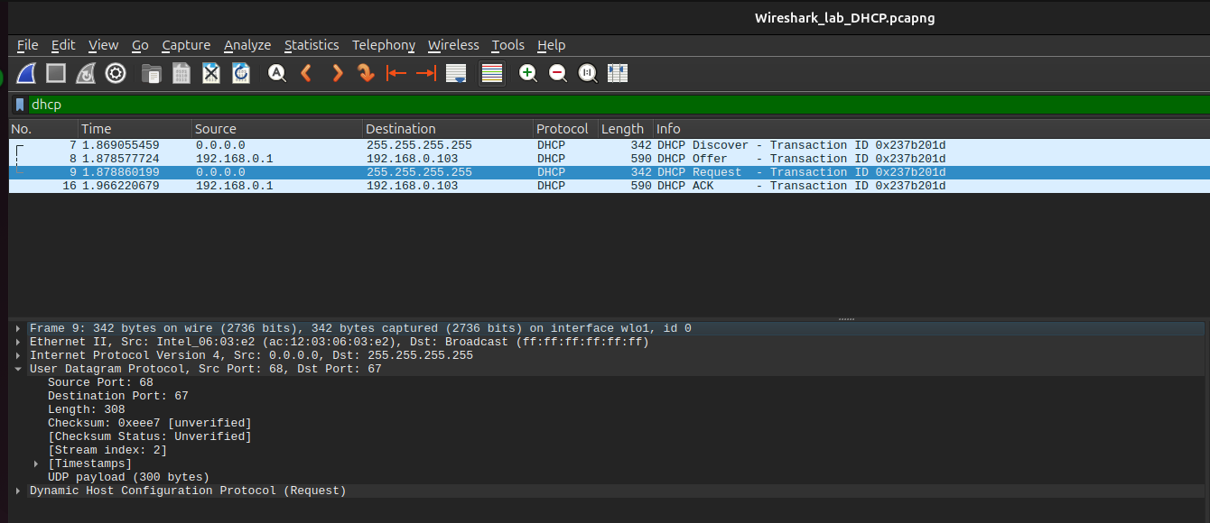

Ans -
Source IP Address - 0.0.0.0
Destination IP Address - 255.255.255.255
- This address is unique since it shows that the client has not yet been given a working IP address.
- The DHCP server is still providing the client with an IP configuration.
- The client uses 0.0.0.0 as a placeholder to indicate "this host, but no IP address assigned yet" since it cannot use a regular source IP until the DHCP process is finished.

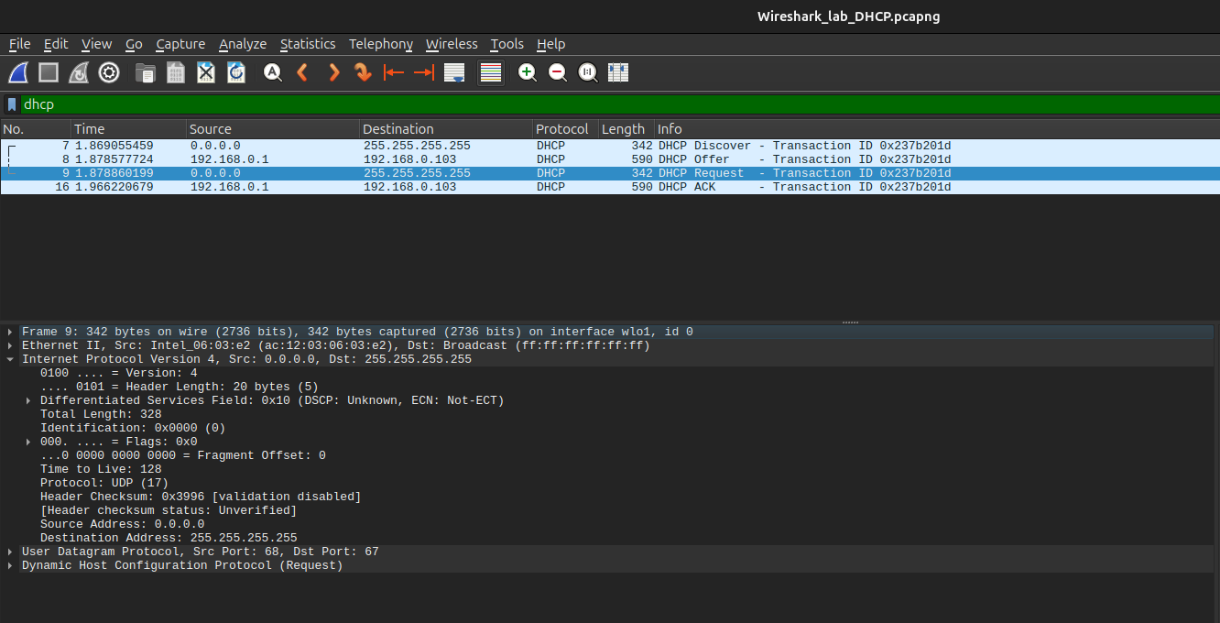

Ans-
Destination IP - 255.255.255.255
- This broadcast address used for delivering the message to all connected devices in local network.
- Now client dont know about server IP or IP of its own.
- Broadcasting makes sure all DHCP servers on the local network get the message, so the correct one can reply with the ACK to confirm the IP assignment

Ans -
Transaction ID : 0x237b201d
All Four Discover, Offer, Request and Ack have the same Transaction ID.

Ans-
Source IP Address: 192.168.0.1
- This is the DHCP server’s (router’s) IP address.
- It’s special because it identifies the device that officially assigns and confirms the client’s IP (192.168.0.103) using the ACK message.
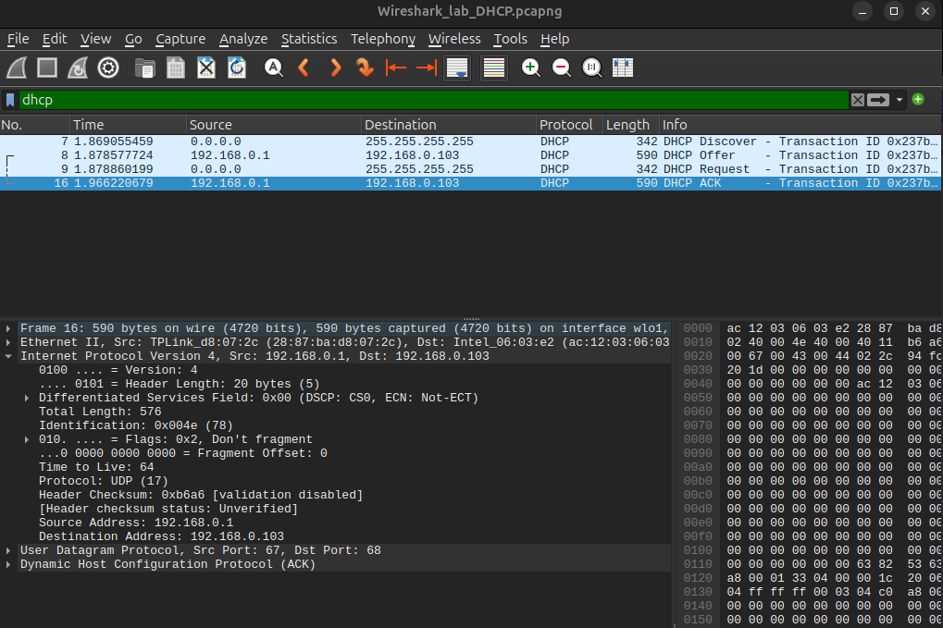

Ans -
Destination IP Address : 192.168.0.103
- This is the DHCP client’s new IP address.
- The server sends the ACK message to confirm that this address is now assigned and ready to use.



Ans-
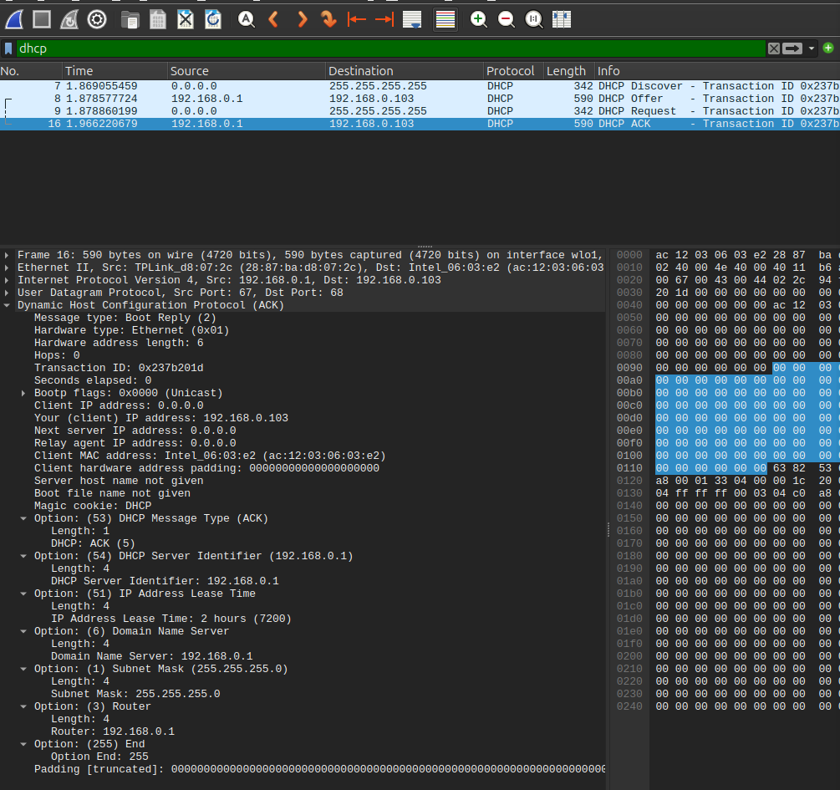

If we see DHCP header we can see –
“Your (client) IP address : 192.168.0.103”

Ans - Lease Time - 2 hours
We can see in the entry -
Option: (51) IP Address Lease Time
Length: 4
IP Address Lease Time : 2 Hours.

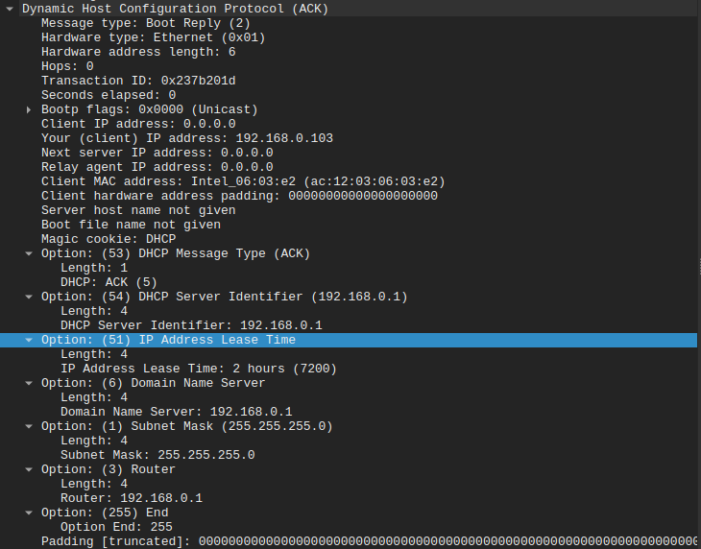

Ans -
Option: (3) Router
Length: 4
Router: 192.168.0.1 <- This is IP Address of Router on default path from client to rest internet.

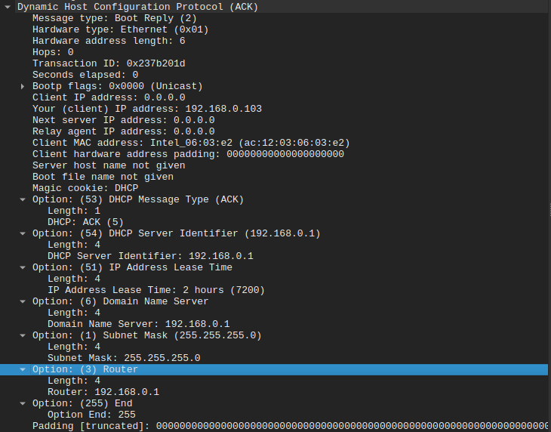

Link for PCAP File -
https://drive.google.com/drive/folders/1zb8DMo2rZvVT9Cy_7_kV0h050rQkX8fE?usp=sharing

